**Music Capstone Project**

Developed by: Mustafa Alhilo, Narges Goshayeshisafa, Connor Richter, Nathaniel Young

HCL America Inc

**Project Description**

An online product catalog that can be browsed: The work starts with adding many new product catalog features which includes displaying categories, products, and product details.

Searching the Catalog: For the visual part, a text box is used in which the visitor can enter one or more words to search through the product catalog. In Music CD Shop,the words entered by the visitor are searched for in the products’ names and descriptions. Also, the user can search for a particular song by entering the title, artist,style, format and the price range.

A Custom Shopping Cart and checkout: A custom shopping basket is implemented, which stores its data into the local database. Also a “shopping cart summary control” is created that shows up in every catalog page except the shopping cart page.

Handling Customer Accounts: In customer account system, details such as credit card numbers are stored in a database so that customers don’t have to retype this information each time they place an order. Customers can log in via a login page or dialog box to get access to secured areas of the web site. Once logged in, the WebApplication remembers the customer until the customer logs out (either manually via a Log Out button or automatically, if the session times out ora server error occurs).All secure pages in a Web Application need to check whether a customer is logged in before allowing access.

Catalog Administration: This administrative interface is implemented for easy management of the web store data. The catalog administration page allows the administrator to:

* Add or remove genres, and update the details of existing genres
* View and manage the categories that belong to a genre• Manage the list of products in a specific category, and edit product details
* Assign an existing product to an additional, or move it to another category
* Remove a product from a category or delete the product from the catalog
* Manage orders by updating their status

**Technologies**

* Spring boot
* Java 8
* MySQL database
* Spring Data JPA
* JSP
* Servlets
* Bootstrap

**Planning Section**

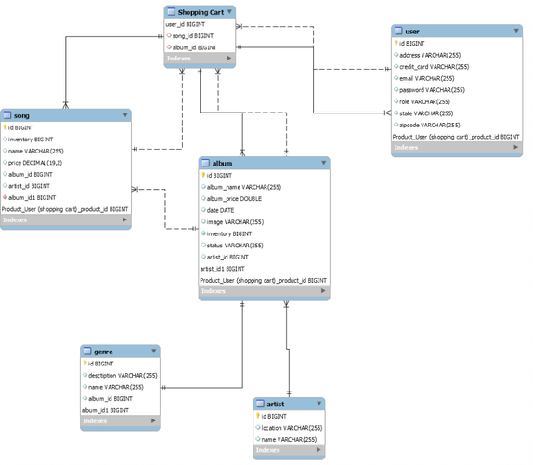

**Entities and Attributes**

User Entity:

id, name, email, password, address, city, state, zip code, credit card number, list of roles, connection to shopping cart

Album Entity:

Id, name, price, artist, date, condition, image url, inventory, genre, song

Genre Entity:

Id, name, description

Song Entity:

Id, name, price, inventory, artist, album, genre

Artist Entity:

Id, name, location, songs, albums

Shopping Cart:

Songs, Albums, User

**Future plans**

* Refactor code to include use of Project Lomebock and Streams for efficiency
* Implement Order Entity for customers to see past orders
* Implement sorting by product condition
* Add more search options to refine results
* Improve user interaction (show adding to shopping cart)
* Add feature to album create/edit to show album preview image
* Add more features to allow user multiple ways to update details

**Technologies Used**

* Eclipse/IntelliJ: An IDE to code for the application
* Java: A programming language to develop the prototype
* Git: To connect and push files from the local system to GitHub
* GitHub: To store the application code and track its versions
* Scrum: An efficient agile framework to deliver the product incrementally
* Specification document: Any open-source document or Google Docs

**Examples**

Login Page

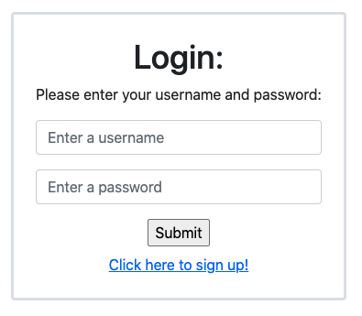

Sign Up

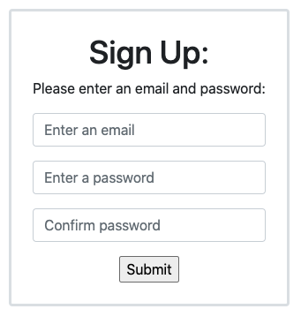

Home Page

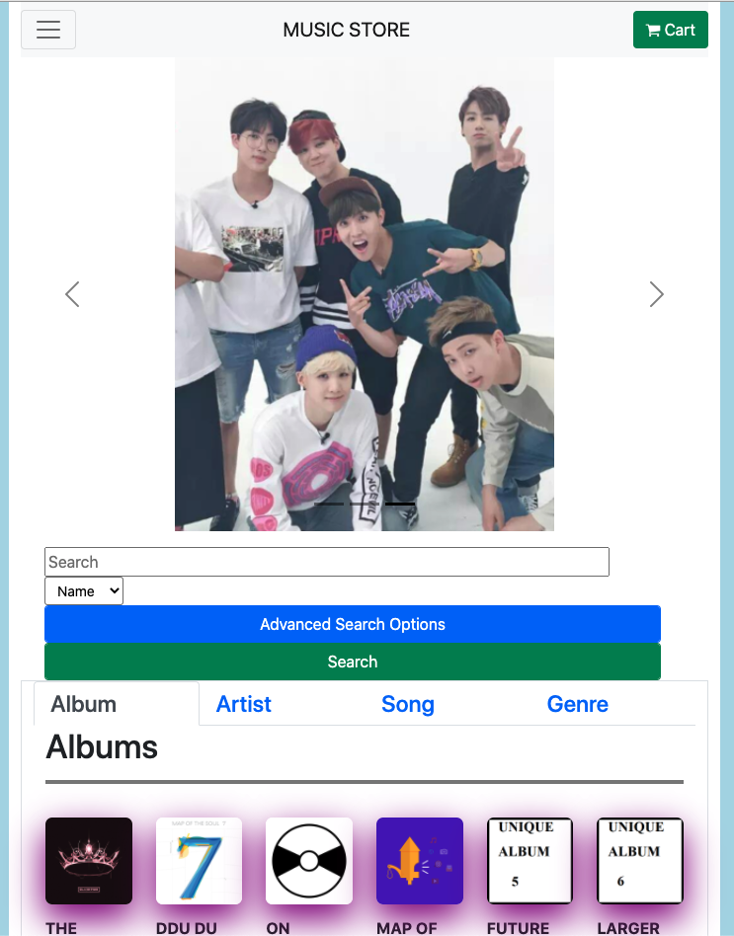

Album Id Page

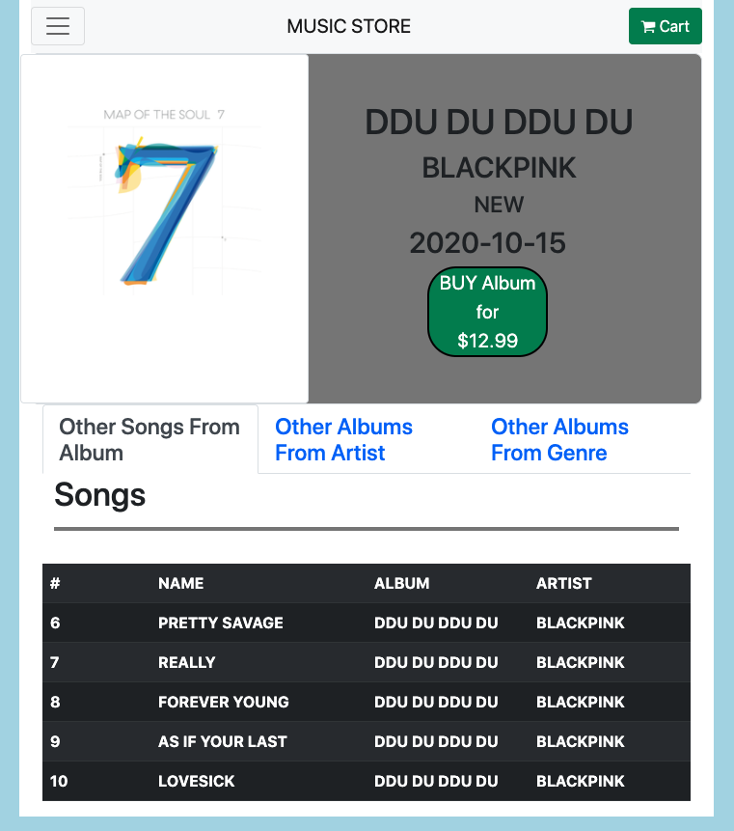

Song Id Page

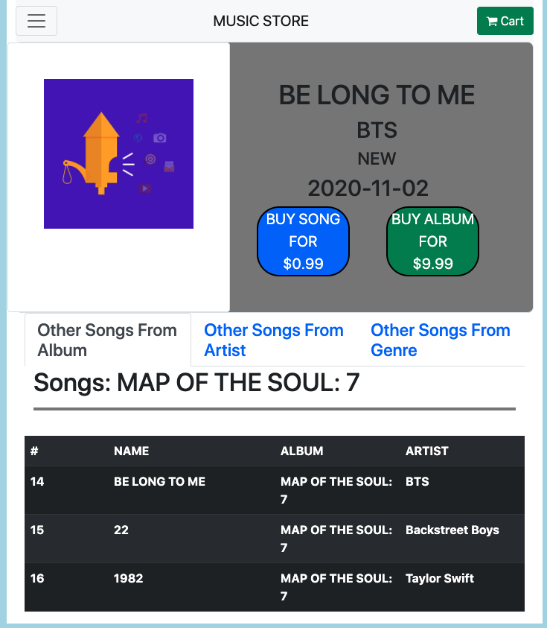

Artist Id Page

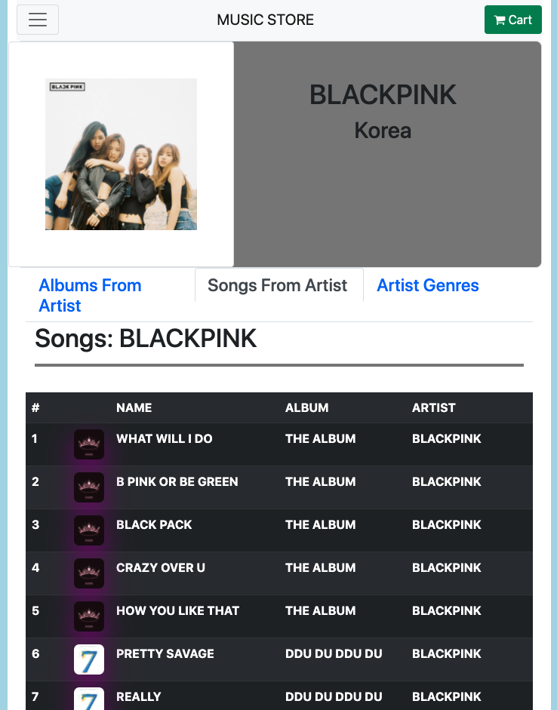

Search Results Page

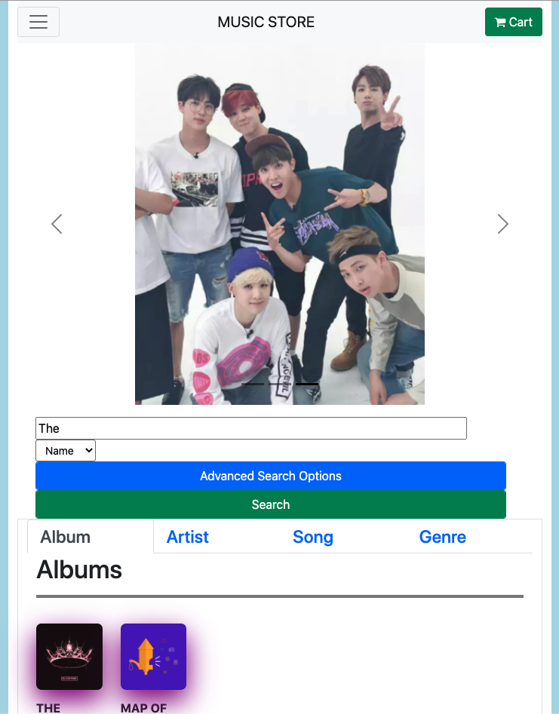

Shopping Cart Page

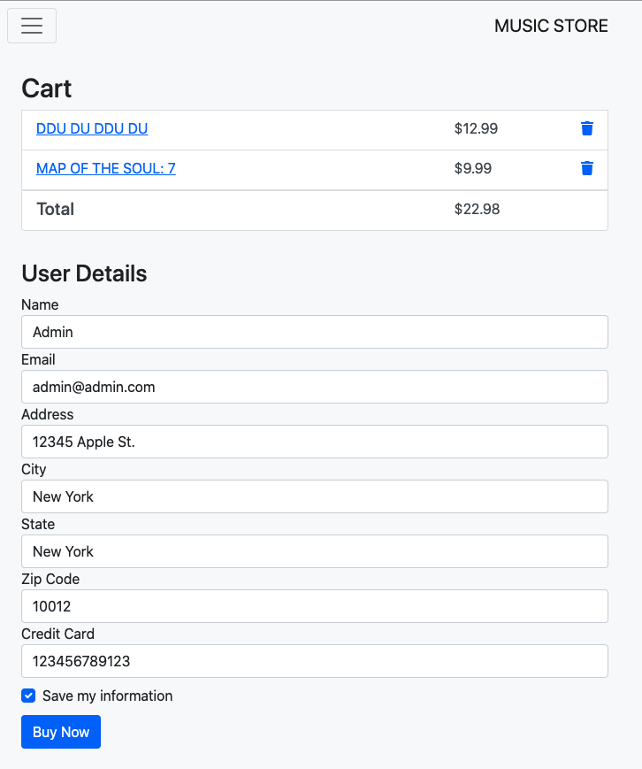

Completed Checkout Page

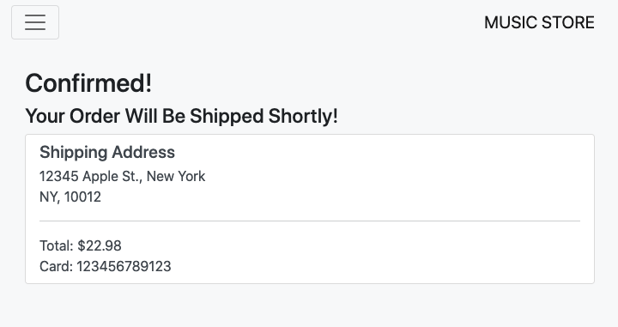

Admin Home Page

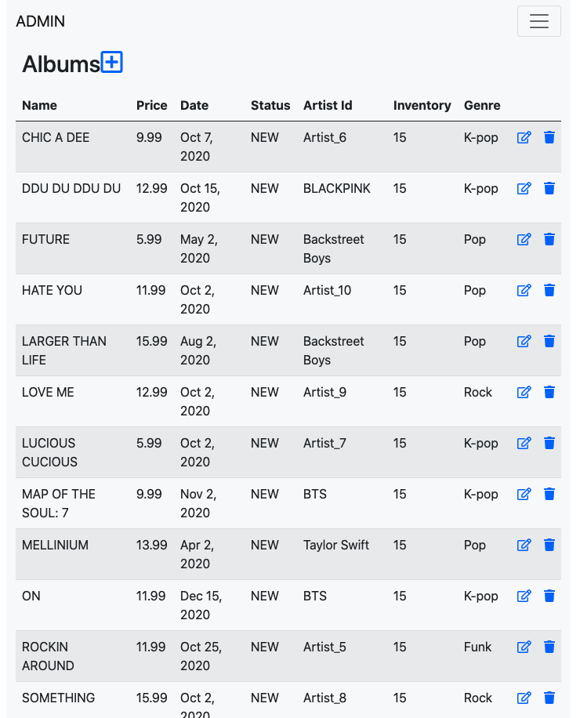

Admin Album Create

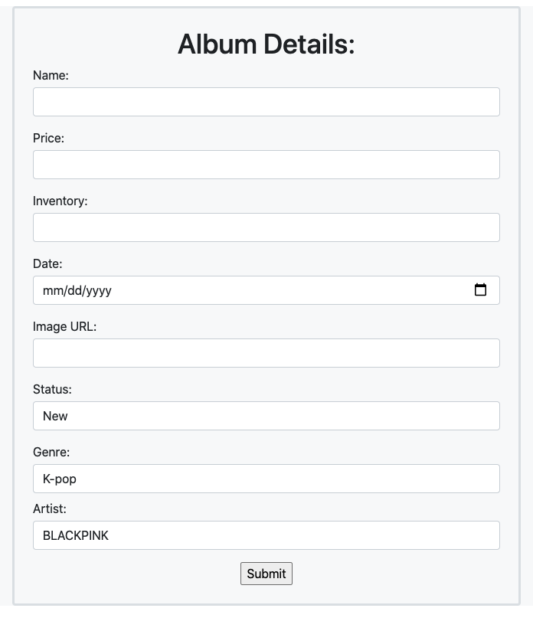

Admin Song Create

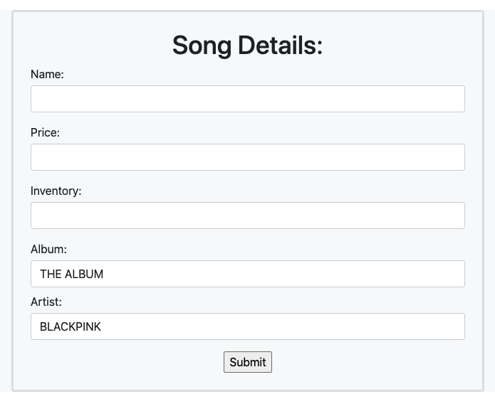

Admin Artist Edit

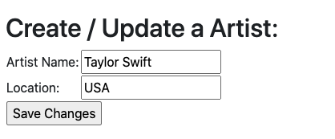

Admin Genre Edit

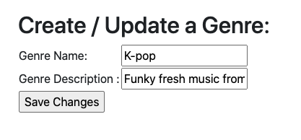

Admin Customer Home

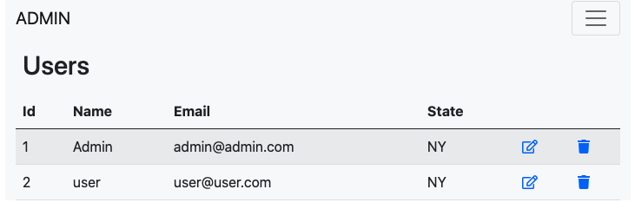

Admin Customer Update

